**CHAPTER 1**

**OBJECTIVE**

**Primary Objective of the Campaign**

* Encourage adoption of digital financial practices in Abbigere, Bangalore.
* Enhance financial inclusion and economic empowerment within the community.
* Educate, engage, and empower residents for a smooth transition to digital finance.
* Promote safer, more efficient, and convenient financial transactions.
* Reduce risks associated with cash handling.
* Instill long-term financial literacy and behavioral change.

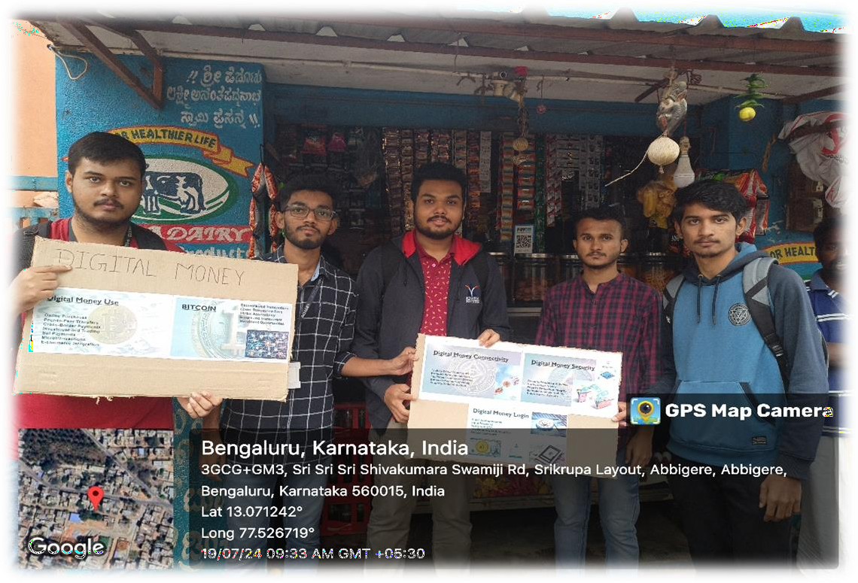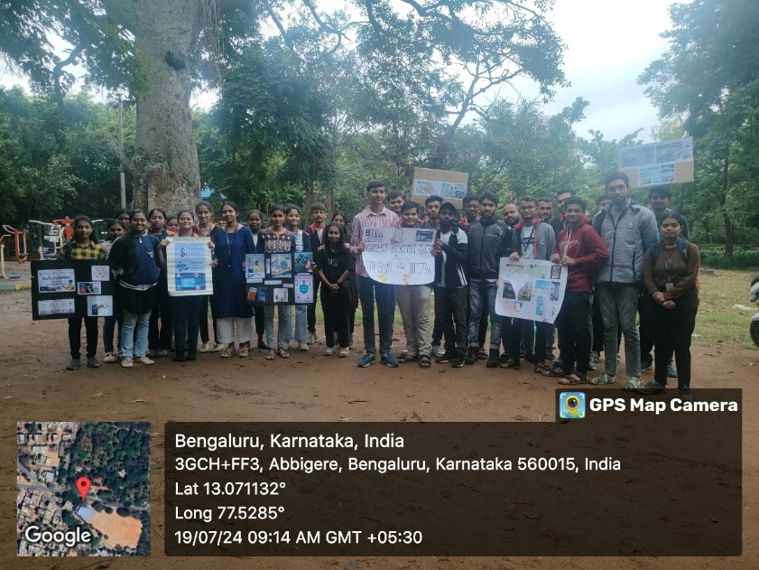

**Specific Goals of the Initiative**

**1. Promotion of Digital Money Usage**

* Increase the use of UPI, mobile wallets, and net banking among residents and businesses.
* Demonstrate the speed, safety, and convenience of cashless transactions.
* Encourage local businesses to implement digital payment options for better efficiency.

**2. Raising Awareness on Digital Transactions**

* Educate people on the benefits of digital money, including reduced theft and fraud.
* Highlight the role of digital transactions in financial transparency and expense tracking.
* Spread information about government initiatives like Digital India and BHIM UPI.

**3. Enhancing Digital Literacy**

* Provide workshops, pamphlets, and guidance on:
  + Setting up and using mobile banking apps.
  + Linking bank accounts with UPI and digital wallets.
  + Ensuring cybersecurity while making digital transactions.

**4. Encouraging Behavioral Change**

* Promote a shift from cash dependency by demonstrating:
  + The ease of digital payments in everyday transactions.
  + The benefits for small businesses and local vendors.
  + The safety and convenience of tracking expenses digitally.

**5. Engaging the Community**

* Build trust and motivate residents to participate in the digital economy.
* Foster open discussions to address concerns and misconceptions about digital payments.
* Involve community leaders, shop owners, and influencers to spread awareness effectively.

**6. Supporting Economic Growth**

* Encourage businesses to adopt digital payments to:
  + Improve financial security by reducing cash dependency.
  + Enhance customer convenience with cashless transactions.
  + Prevent revenue loss from counterfeit currency or cash mismanagement.

**7. Spreading Awareness on Financial Security**

* Educate people on digital security and safe online transactions.
* Teach best practices to prevent fraud, phishing scams, and unauthorized access.
* Guide residents on recognizing secure payment platforms and safeguarding financial details.

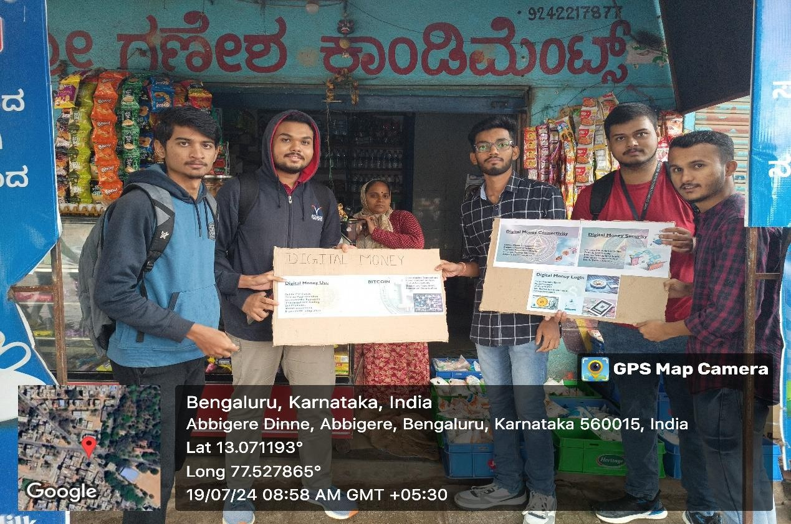



**CHAPTER 2**

**ABOUT THE PLACE**

• **Location and Development**

* Abbigere is a rapidly developing locality in northern Bangalore, Karnataka.
* Situated approximately 15 km from Bangalore city center.
* Transitioned from a rural settlement to a semi-urban neighborhood.
* Experiences significant infrastructural and commercial growth while retaining some suburban characteristics.

• **Demographics and Community Structure**

* Diverse population including local Kannada-speaking residents, professionals, students, and migrants.
* Growing presence of educational institutions, healthcare facilities, and businesses.
* Strong sense of community with a mix of traditional values and modern influences.

• **Economic and Commercial Growth**

* Growth driven by local businesses, retail stores, and service sectors.
* Small-scale industries, trade centers, and local markets support economic activity.
* Presence of banks, grocery stores, and shopping centers make it self-sustained.
* Predominantly cash-based transactions, highlighting the need for digital financial adoption.

• **Educational and Technological Influence**

* Presence of multiple schools, colleges, and coaching centers.
* Many students commute to reputed institutions in Bangalore.
* Younger generation is technologically inclined, encouraging digital financial adoption.
* Digital literacy programs can aid in transitioning to cashless transactions.

**• Infrastructure and Connectivity**

* Well-connected to key areas of Bangalore via roads and public transport.
* Availability of bus services, auto-rickshaws, and cab facilities.
* Connected to important hubs like Yeshwanthpur, Jalahalli, and Mathikere.
* Future metro expansion and road development projects will enhance accessibility.

• **Cultural and Social Aspects**

* Blend of traditional practices and modern lifestyles.
* Major festivals like Ugadi, Deepavali, and Sankranti are celebrated widely.
* Presence of temples, parks, and community centers promotes social interaction.
* Younger population increasingly adopts digital lifestyles, bridging financial habits.

• **Challenges in Financial Modernization**

* Slow adoption of cashless transactions among small businesses and elderly residents.
* Limited digital literacy and concerns about transaction security.
* Lack of awareness about digital financial benefits.
* Need for digital literacy programs and awareness campaigns to promote financial transformation.

**CHAPTER 3**

**ACTION PLAN**

|  |  |  |  |  |
| --- | --- | --- | --- | --- |
| **SLNO** | **DATE** | **ACTIVITY** | **DURATION** | **REMARKS** |
| 01 | 10-07-2024 | Seeking Permission | 3 | Obtained Permission |
| 02 | 10-07-2024 | Choosing Location | 3 | Found location |
| 03 | 11-07-2024 | Action plan on posters | 3 | Action plan mapped |
| 04 | 12-07-2024 | Collecting materials | 7 | Materials collected |
| 05 | 13-07-2024 | Collecting materials | 7 | Materials collected |
| 06 | 14-07-2024 | Preparing agenda | 5 | Agenda prepared |
| 07 | 15-07-2024 | Travelling | 7 | Total travel time |
| 08 | 15-07-2024 | Interacting with locals | 7 | Facilitated agenda to local vendors |
| 09 | 16-07-2024 | Collecting details and geo tag photos | 7 | Details collected |
| 10 | 16-07-2024 | Report making | 3 | Made report |

**CHAPTER 4**

**CONDUCTION OF THE ACTIVITY**

**Planning and Preparation**

* Developed a detailed campaign plan outlining objectives, strategies, and promotional methods.
* Conducted preliminary research on financial habits through surveys and informal discussions.
* Assessed residents' familiarity with digital payments and the challenges they faced.
* Created educational materials (brochures, pamphlets, posters) explaining digital transactions.
* Designed strategies to address concerns about digital fraud, transaction failures, and accessibility.

**Implementation and Awareness Campaign**

* **Launched campaign** at key locations such as marketplaces, residential areas, small businesses, and public spaces.
* **Direct community interaction** to encourage digital financial adoption.

**1. Demonstrations of Digital Payment Methods**

* Live demonstrations of UPI transactions, mobile wallets, and net banking.
* Training on Google Pay, PhonePe, and Paytm for digital transactions.
* Special focus on educating elderly residents and small business owners.

**2. Engaging Local Businesses and Vendors**

* Encouraged shopkeepers, street vendors, and small businesses to adopt digital payments.
* Assisted businesses in setting up payment platforms and linking bank accounts.
* Explained benefits of cashless transactions, addressing security and convenience concerns.

**3. Distribution of Educational Materials**

* Distributed pamphlets and brochures with step-by-step guides on digital transactions.
* Covered UPI registration, mobile wallet linking, and online fraud prevention.
* Ensured materials served as references even after the campaign ended.

**4. Conducting Interactive Sessions and Public Discussions**

* Organized small-group interactive sessions to answer residents' questions.
* Addressed concerns about transaction security, internet dependency, and fraud prevention.
* Financial experts and student volunteers helped dispel myths and build trust in digital payments.

**5. Providing Hands-On Assistance**

* Offered one-on-one guidance in setting up digital payment apps and linking bank accounts.
* Helped residents and business owners make their first transactions.
* Personalized support boosted confidence in digital financial tools.

**6. Spreading Awareness Through Word of Mouth and Community Leaders**

* Engaged local influencers, religious leaders, and business association members.
* Community leaders endorsed digital payments, gaining residents’ trust.
* Increased willingness among residents to adopt digital financial solutions.

**Challenges Faced and Overcoming Them**

* **Resistance to Change:** Some residents, especially older individuals, were reluctant to change their traditional way of handling money. The campaign addressed this by demonstrating the security and ease of digital transactions.
* **Limited Awareness and Digital Literacy:** Many people were unaware of how digital payment systems worked. The team provided patient, step-by-step guidance to educate them.
* **Concerns About Cybersecurity:** Fear of fraud and online scams was a major deterrent. To counter this, the campaign emphasized security measures such as two-factor authentication and safe banking practices.
* **Lack of Internet Access or Smartphones:** A small section of the population did not have access to internet-enabled smartphones. In such cases, alternative solutions such as SMS-based banking and assisted transactions were suggested.

**Impact and Observations**

The key outcomes observed included:

* A significant increase in the number of shopkeepers and vendors using QR code-based payments.
* A rise in UPI transactions among younger individuals and working professionals.
* Greater awareness about financial security and fraud prevention.
* Positive feedback from community members who found digital transactions more convenient and time-saving.

**OUTCOMES**

**Promotion of Digital Money in Abbigere: Key Highlights**

* Significant step towards financial inclusion by encouraging cashless transactions.
* Well-structured campaign with awareness programs, live demonstrations, and personalized assistance.
* Successfully introduced residents and businesses to the benefits of digital payments.
* Addressed concerns related to security, accessibility, and usability.
* Overcame initial barriers that prevented adoption of digital financial solutions.

**Key Takeaways from the Initiative**

* Positive shift in financial behavior among community members.
* Increased adoption of digital payments by shopkeepers, vendors, and individuals.
* Enhanced safety, efficiency, and transparency in financial transactions.
* Emphasized digital literacy, ensuring users understood:
  + How to use digital payment systems.
  + Best practices for secure financial management.

**Challenges and Lessons Learned**

* Initial resistance and technological barriers were present.
* Persistent education, hands-on engagement, and community involvement were crucial for success.
* Encouraging response from residents, many pledging to continue using digital financial services.

**Future Roadmap for Sustained Impact**

* Expand and sustain efforts to reach more individuals, especially in underserved communities.
* Continue awareness campaigns to reinforce digital financial literacy.
* Leverage government incentives and infrastructure improvements to strengthen digital adoption.
* Bridge the digital divide by empowering communities with necessary knowledge and resources.